Pre-Final Test

**Test 1**

**Date:** 2021/04/06

**Tester:** Lide Cui

**Author:** Shichuang Zhang, Junjian Chen

**Hardware version:** 1.5 (in Part 2.5 of [Hardware Document](https://docs.google.com/document/d/11jkA_S_xBqyCbcn2NyMuM-OMDEybDfRy/edit#))

**Software version:** 2.0 (in Part 7.0 of [Software Document](https://docs.google.com/document/d/19JaY5629aUu4Y4rjoQJ-jWyeQLqNSAcr/edit))

**Test Purpose:**

Test the performance of the robot in a simulated map.

**Test Procedure:**

Disable server, import map data from xml file and run the robot.

1. Robot will be placed at a red or green island by location.
2. Given time limit of 5 minutes, observe performance of the robot in following parts:
3. localization
4. across bridge
5. traverse waypoints
6. avoid obstacle
7. go up and go under the overpass
8. return home

**Test Data:**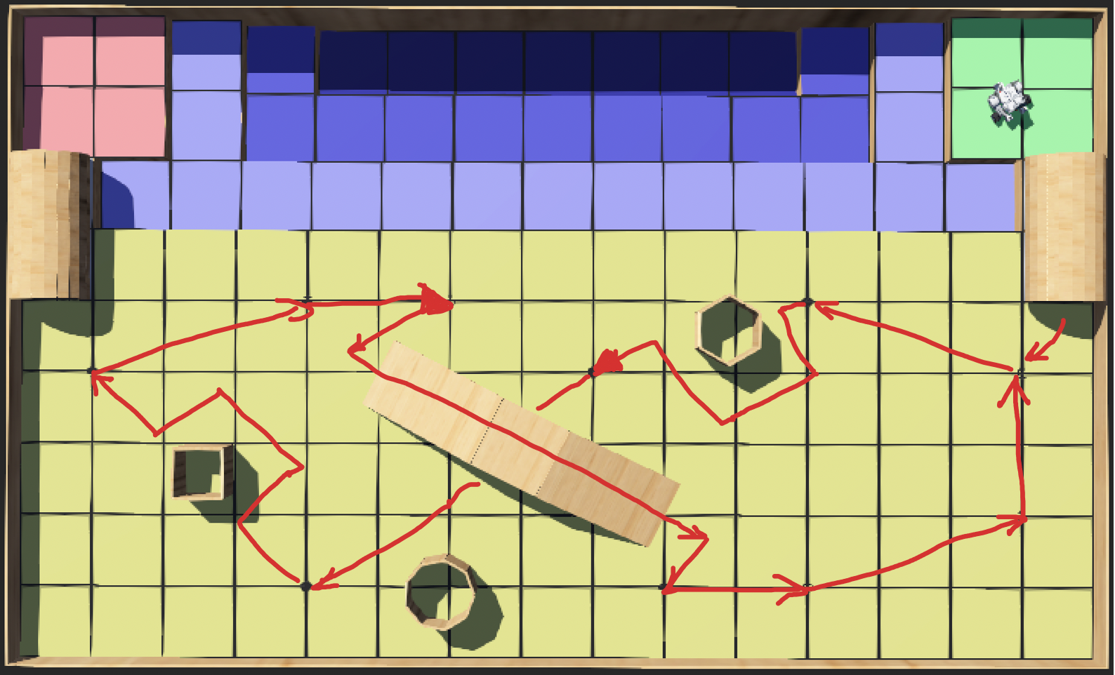

detailed data can be found in example_data_file.xml

**Expected Result:**

|  |  |
| --- | --- |
| **Task** | **Comment** |
| localization | The robot should identify itself at green corner |
| across bridge | The robot should go from green corner to island |
| traverse waypoints | The robot can traverse each each point |
| avoid obstacles | The robot should avoid obstacles |
| go up and go under overpass | The robot should identify special point to go up or go under the overpass |
| return home | The robot should be able to return home after one iteration. |

**Test Results:**

|  |  |
| --- | --- |
| **Tasks** | **Result** |
| localization | The robot identified itself at (14, 8) |
| across bridge | The robot crossed bridge from (14.5, 7.5) to (14.5, 4.5) |
| traverse waypoints | The robot rearranged the waypoints and traversed (14, 4), (11, 5) in sequence |
| avoid obstacles | The robot dropped into the sea when it tried to avoid obstacle between (11,5) and (8,4) |
| go up and go under overpass | Not able to test |
| return home | Not able to test |

**Test Report:**

The robot failed the pre-final tests, due to its incapability of avoiding obstacles. It fell into the sea due to turning left first, but it could not identify the sea.

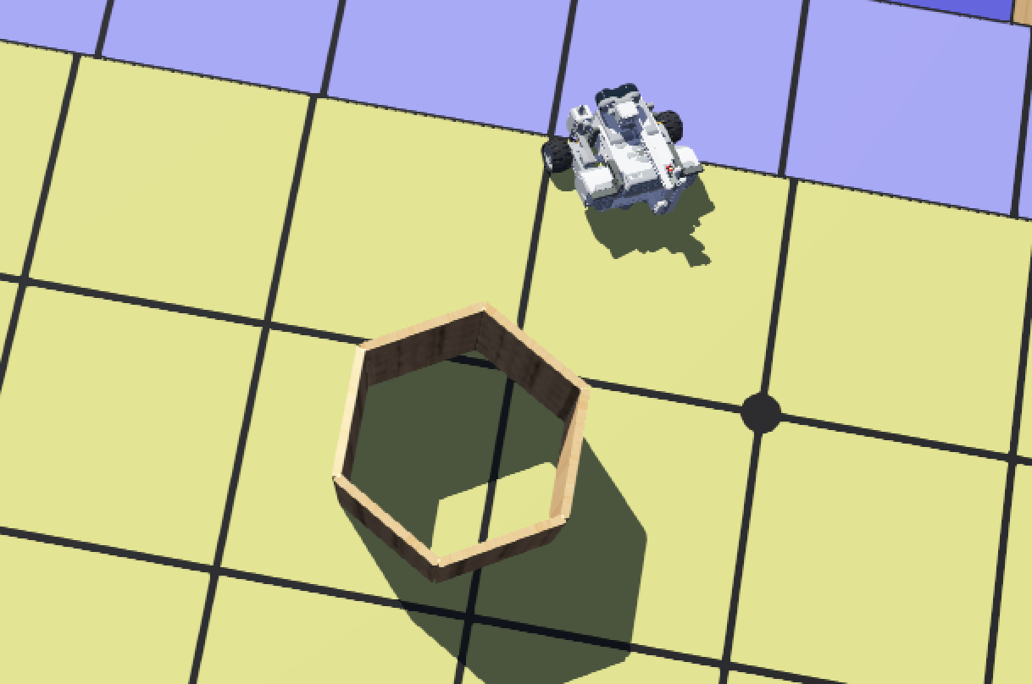

**Conclusion:**

Tests do not pass due to obstacle avoidance

**Action:**

1. Revise the obstacle avoidance: When calculating a new path which avoids the obstacle, the algorithm should check whether the new points on the path belong to the island. If not, it should try to calculate a different path.

**Distribution:** Software development

**Test 2**

**Date:** 2021/4/11

**Tester:** Junjian Chen

**Author:** Junjian Chen

**Hardware version:** 1.5 (in Part 2.5 of [Hardware Document](https://docs.google.com/document/d/11jkA_S_xBqyCbcn2NyMuM-OMDEybDfRy/edit#))

**Software version:** 2.3 (in Part 7.0 of [Software Document](https://docs.google.com/document/d/19JaY5629aUu4Y4rjoQJ-jWyeQLqNSAcr/edit))

**Test Purpose:**

Test whether the robot is able to pass the tunnel from its start point.

**Test Procedure:**

1. Place the robot on 45 degree line at the corner
2. Start the simulation
3. Observe whether the robot is able to pass the tunnel, record in which part the robot passes or fails.
4. If the robot completes the whole process successfully, calculate the error distance
5. Repeat each trial for 5 times

**Test Data/Expected Result:**

Testing Map for Trial 1-5,6-10:

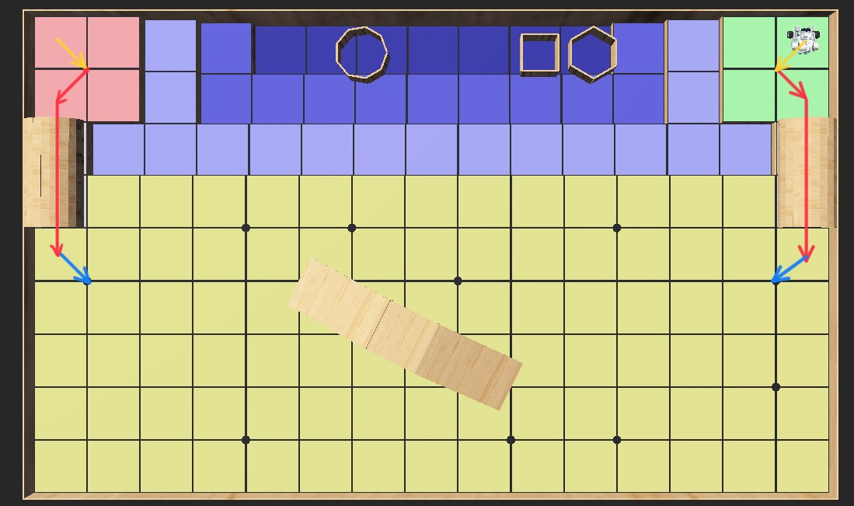

Testing Map for Trial 11-15,16-20:

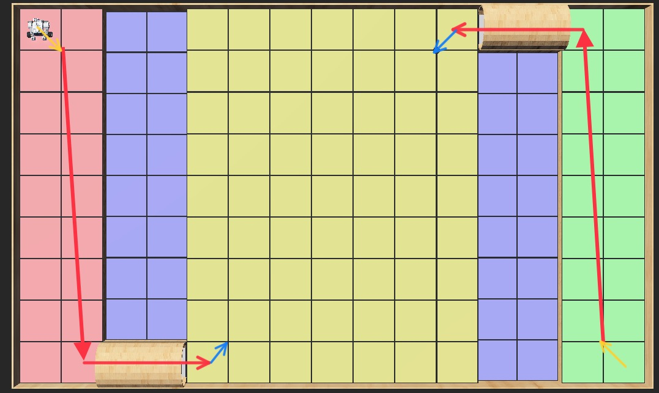

The robot is able to:

1. Finish ultrasonic/light localization through the yellow path
2. Finish the tunnel passing through the red path
3. Finish after-tunnel light localization through the blue path

**Test Results:**

|  |  |  |  |  |
| --- | --- | --- | --- | --- |
| Trial# | Fail/Pass | Expected Final Position/(x,y) | Actual Final Position/(x,y) | Error Distance/Feet |
| 1 | Pass | (1,4) | (0.98,3.98) | 0.028 |
| 2 | Pass | (0,97,3.98) | 0.036 |
| 3 | Pass | (0.96,4.03) | 0.05 |
| 4 | Pass | (1.01,4.01) | 0.014 |
| 5 | Pass | (1.02,4) | 0.02 |
| 6 | Pass | (14,4) | (14.01,4.01) | 0.014 |
| 7 | Pass | (14.01,4.01) | 0.014 |
| 8 | Pass | (14.04,3.99) | 0.041 |
| 9 | Pass | (13.99,3.99) | 0.014 |
| 10 | Pass | (13.97,4.02) | 0.036 |
| 11 | Pass | (5,1) | (5.01,1.01) | 0.014 |
| 12 | Pass | (4.98,0.99) | 0.022 |
| 13 | Pass | (5.05,1.03) | 0.058 |
| 14 | Pass | (5.02,1.04) | 0.045 |
| 15 | Pass | (4.99,1.01) | 0.014 |
| 16 | Pass | (10,8) | (10,7.96) | 0.04 |
| 17 | Pass | (10.01,8.02) | 0.022 |
| 18 | Pass | (9.98,7.99) | 0.022 |
| 19 | Pass | (9.97,8.03) | 0.03 |
| 20 | Pass | (10.02,8.01) | 0.022 |

**Test Report:**

Pass Rate:100%

Average Error Distance: 0.0271

All trials pass the test and the average error distance is within acceptance.

**Conclusion:** The test passes.

**Action:** None

**Distribution:** Software Development